IAM Crown-Jewel Capture
As a member of Secure-corp's security team, I am responsible for identifying suspicious activities related to User Granted with Full Privileges

Description
The primary objective of this challenge is to detect and investigate suspicious activities of user account which is granted with Full Privileges within an Enterprise AWS environment.
I will act as a security analyst to identify and investigate logs and events which are accumulated from the CloudTrail to identify such activities. The challenge will assess my knowledge of AWS CloudTrail, Authentication and best practices for monitoring and securing AWS services like IAM.
- Initial Access:
I am provided with access to the ELK and permissions to view CloudTrail logs.
- AWS Resources:
AWS CloudTrail is enabled and configured to log all API activities within the AWS account.
Why Monitoring User Granted with Full Privileges is crucial
Monitoring activities of User Granted with Full Privileges is essential for Security, Access Control, Compliance, Risk Management, Operational Continuity:
- Security: Detects unauthorized elevation of privileges that could result in unrestricted access to sensitive data, systems, or resources, potentially leading to data breaches or malicious activities.
- Access Control: Ensures that privileges are assigned based on least privilege principles, minimizing the risk of unauthorized access and reducing the attack surface for potential security threats.
- Compliance: Helps organizations maintain compliance with regulatory requirements (e.g., PCI-DSS, SOC 2) by monitoring and auditing privilege escalation activities to ensure proper access controls and governance.
Attack Flow
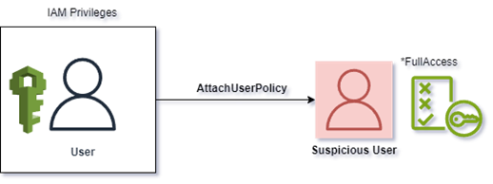

Solution
Investigative Mind Map
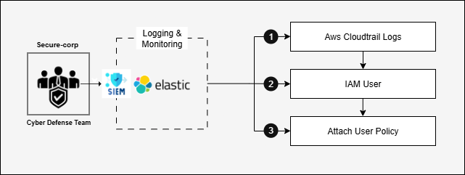
- Log into the SIEM Tool provided after launching your lab with the credentials given
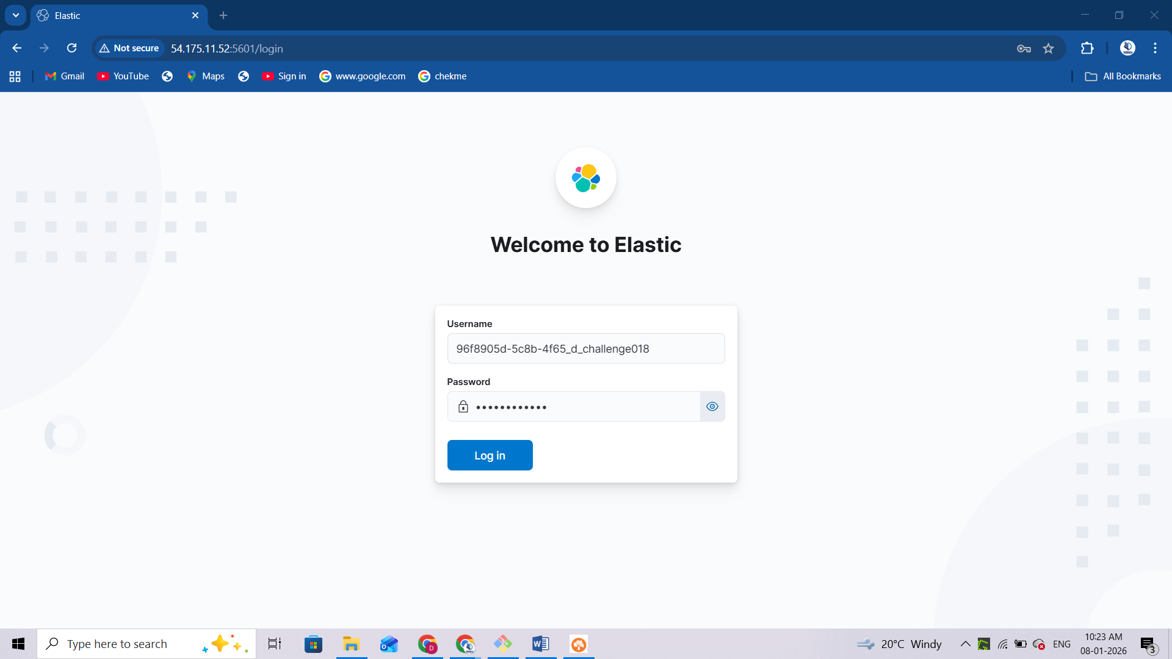
After logging in you should see the elastic homepage as shown below
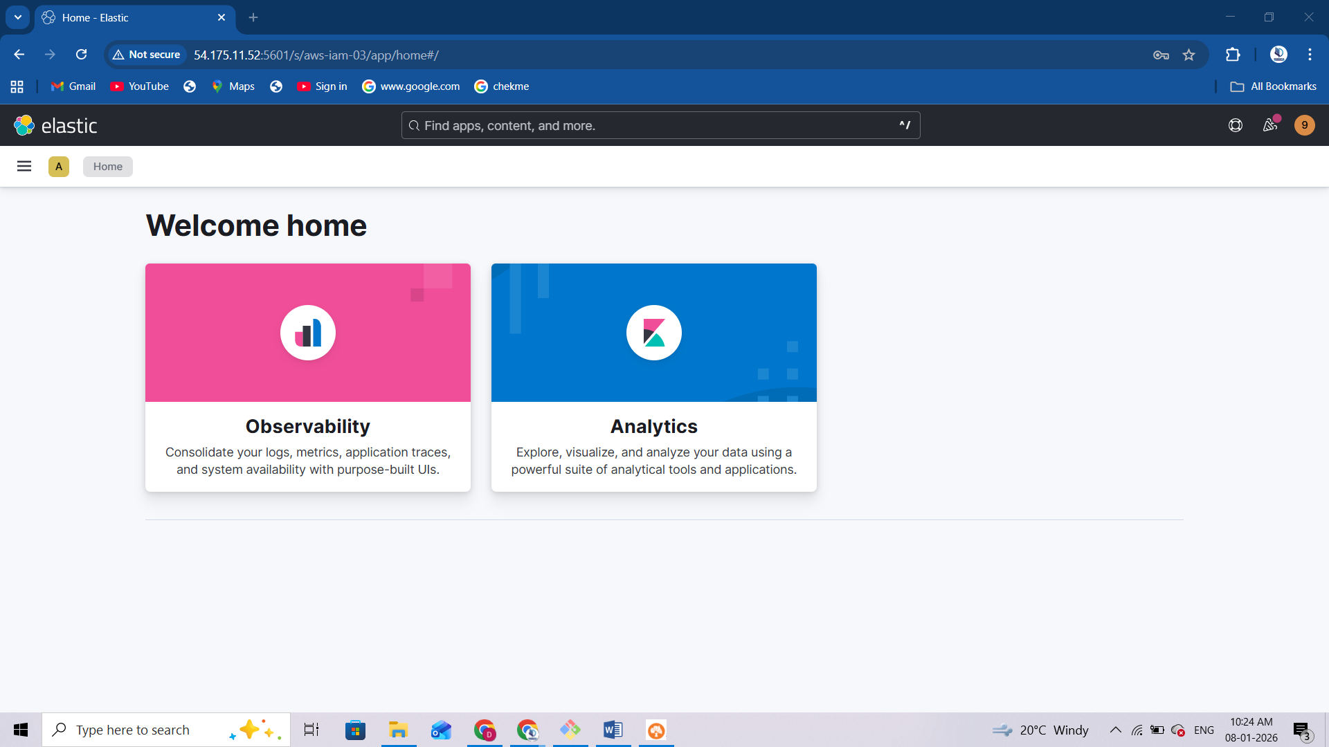
- Navigate to the Analytics → Discover section over the logged in SIEM
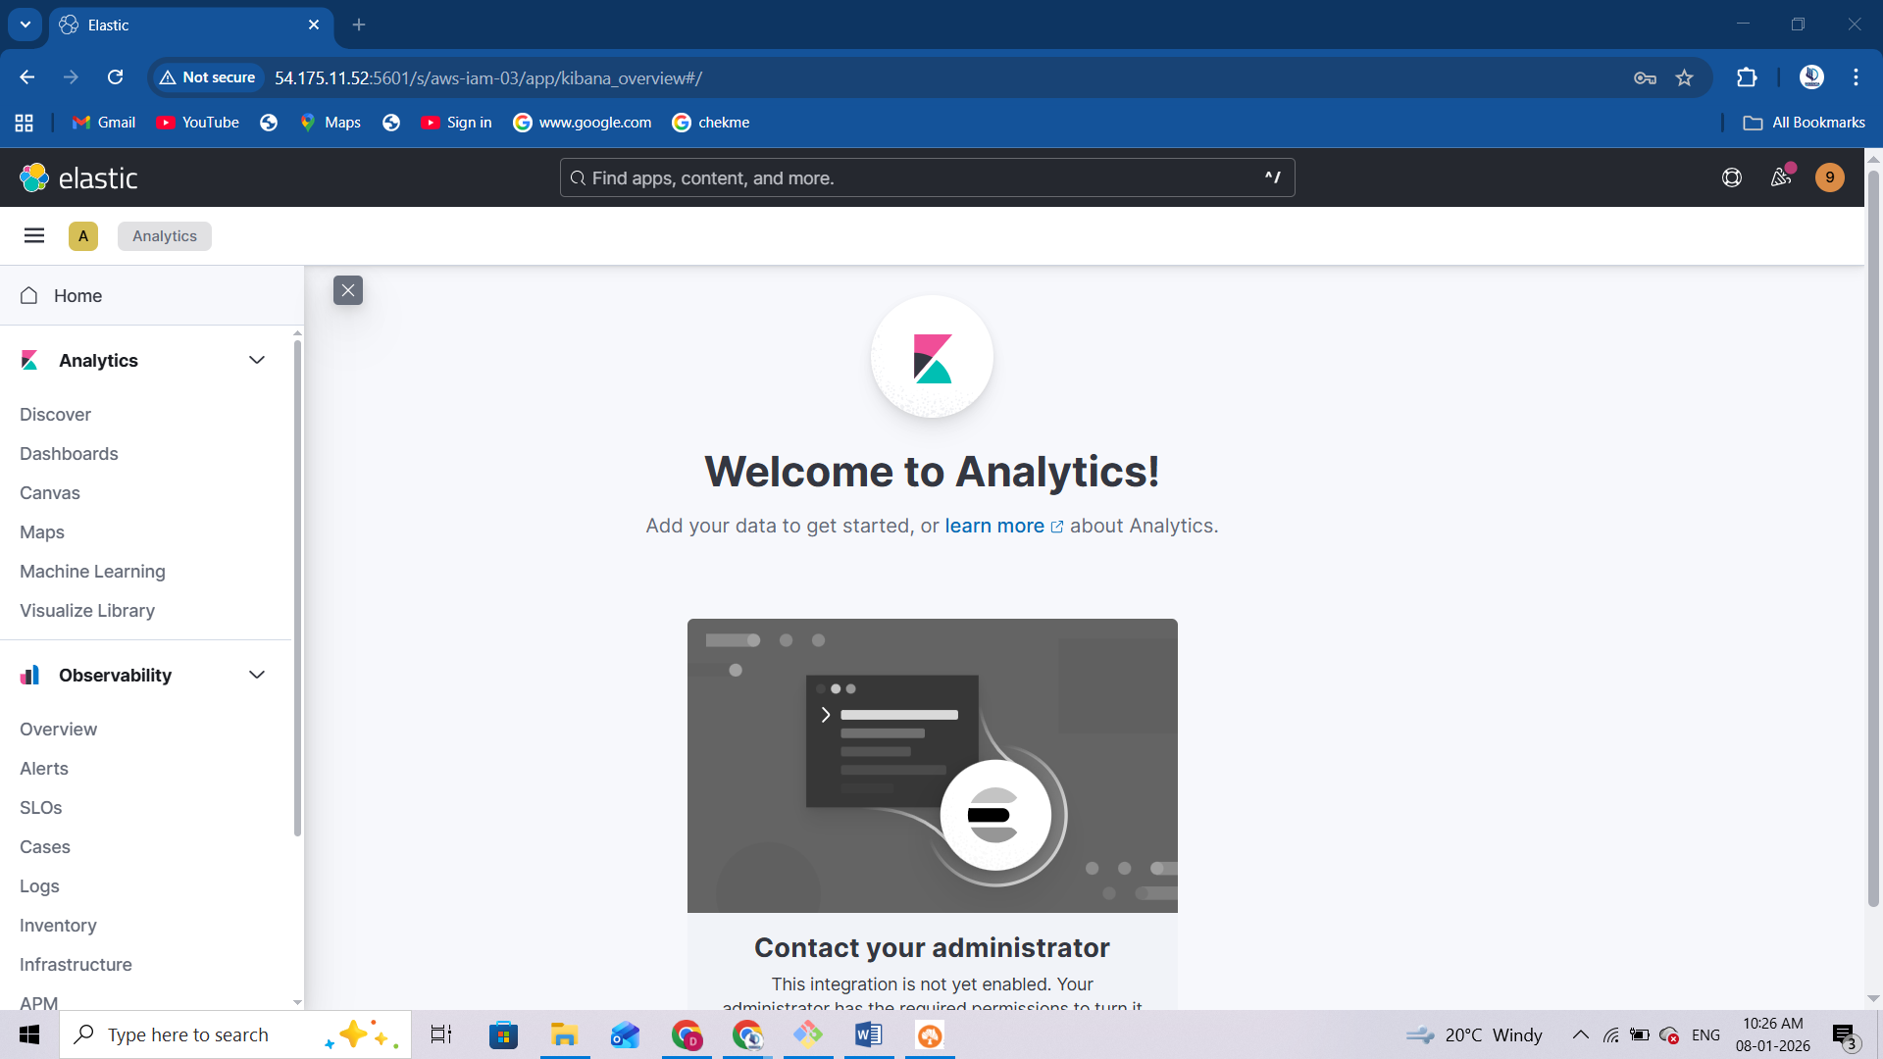
Targeted Investigation of CloudTrail logs
- Execute below query, to filter out events that are specifically relevant to CloudTrail logs: command: event.dataset: aws.cloudtrail
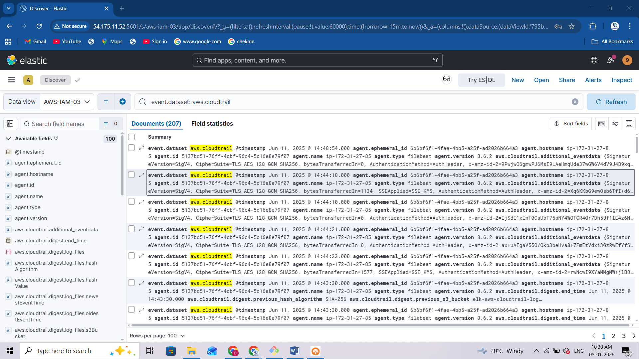
CloudTrail logs generally contain detailed records of information, including event time, source, name, user identity, resource information, and more. Security investigation teams often gather and analyze CloudTrail logs to perform various security investigations.
- Prioritise the IAMUser activity: filter out IAMUSER activity, we can effectively conduct various investigations, similar to analyzing login activity. Command: event.dataset: aws.cloudtrail and aws.cloudtrail.user_identity.type: IAMUser
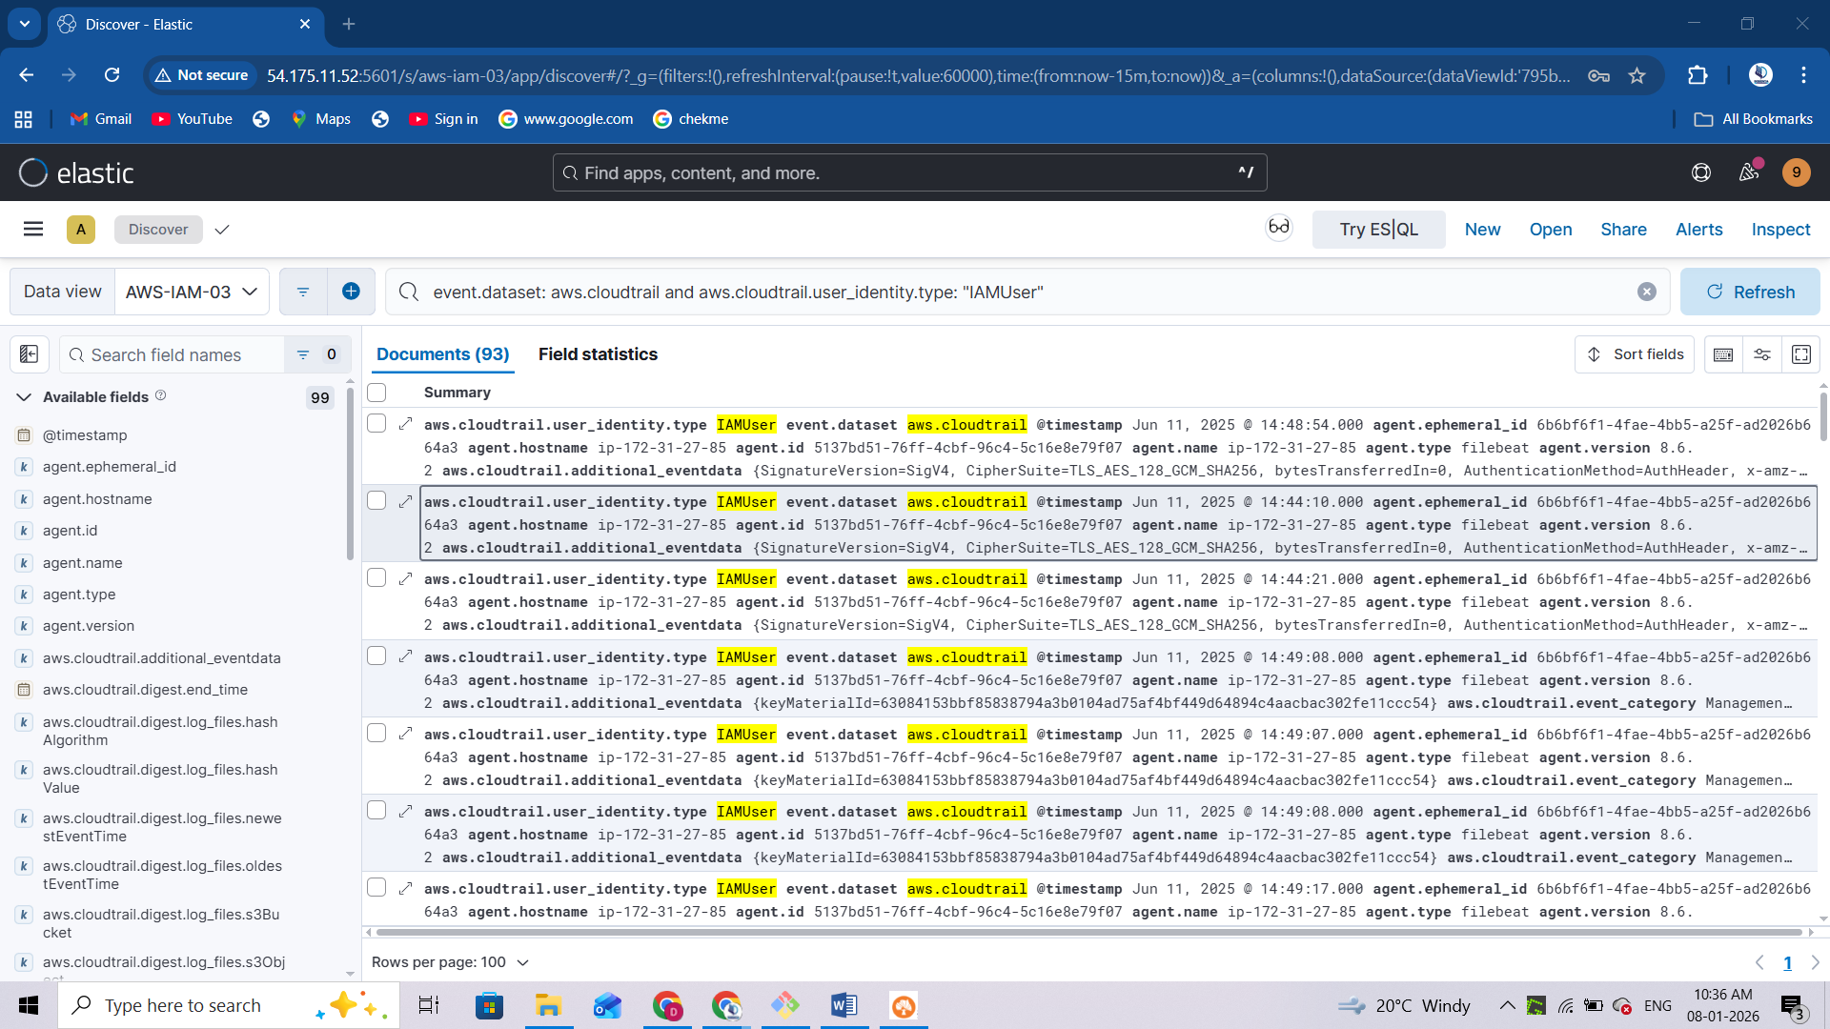
- Investigate activity get associated with AttachUserPolicy filtering out this event action, we can effectively conduct investigations specifically focused on user grants with policy events. Command: event.dataset: aws.cloudtrail and aws.cloudtrail.user_identity.type: IAMUser and event.outcome: "success" and event.action: "AttachUserPolicy"
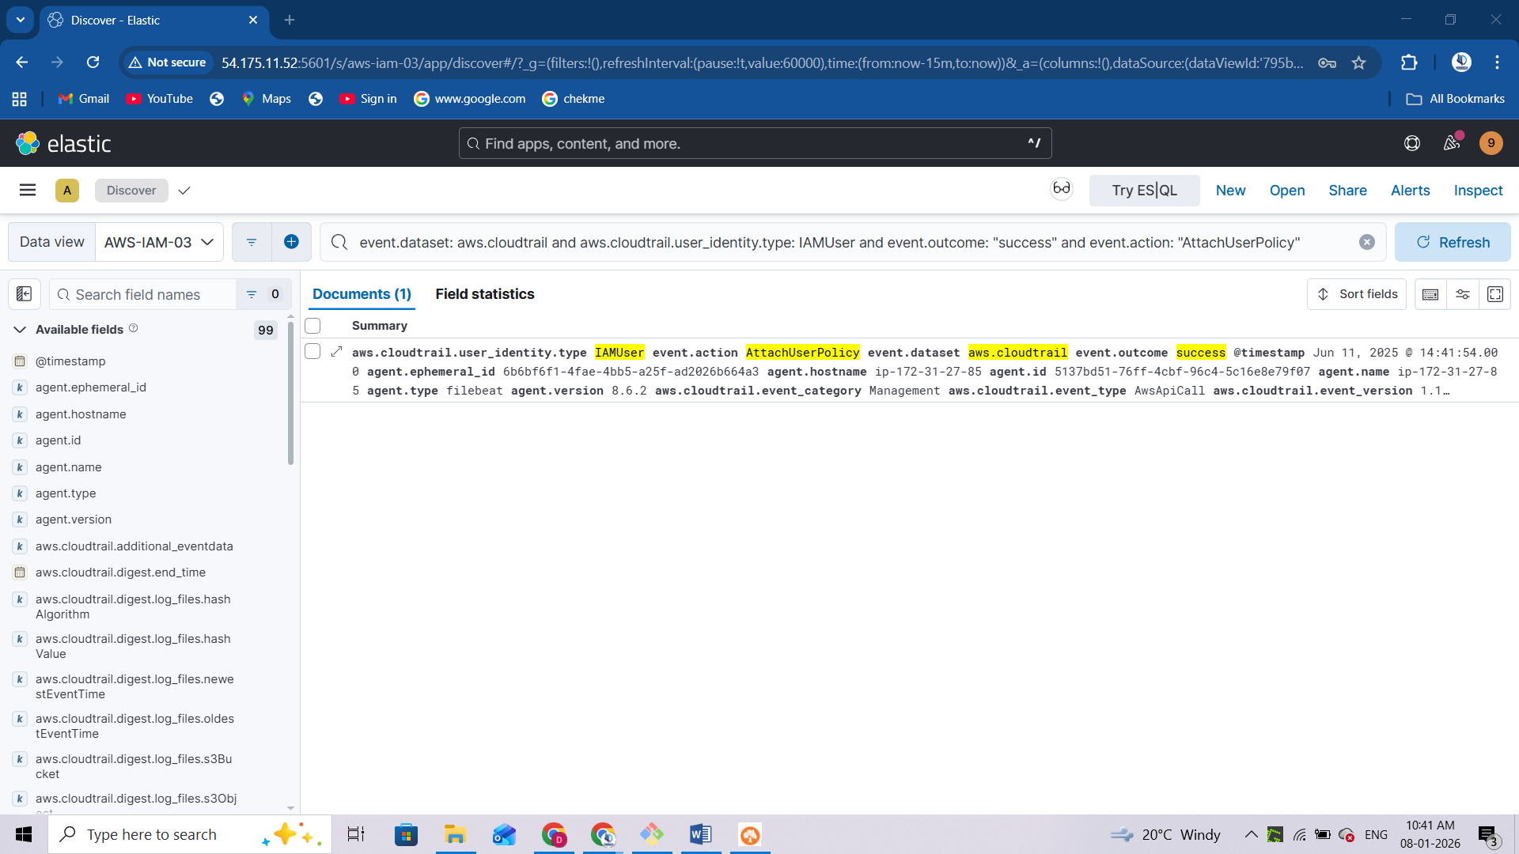
- Prioritize the activity get associated with FullAccess filter out the event which get associated with FullAccess over the access granted activity command: aws.cloudtrail.user_identity.type: IAMUser and event.outcome: "success" and event.action: "AttachUserPolicy" and aws.cloudtrail.request_parameters : *FullAccess*

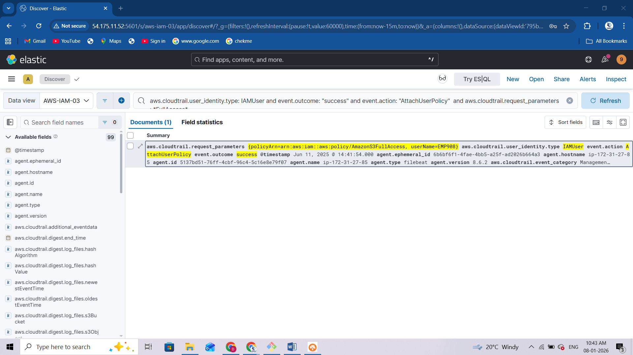
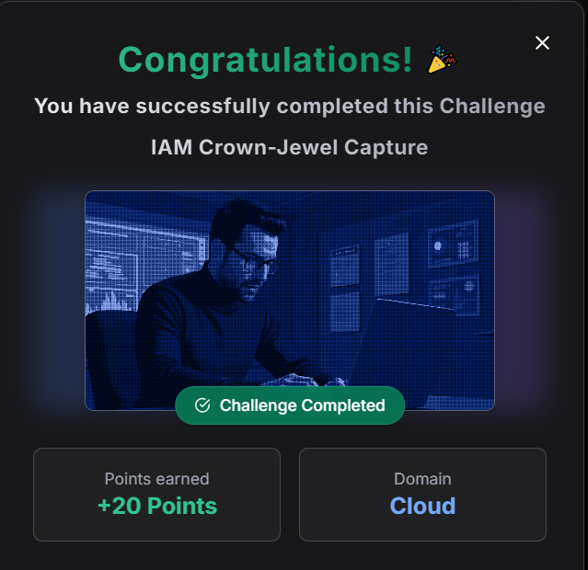

Console Siege
As part of the security team of Secure-corp, the participant is tasked with identifying suspicious activities like multiple failed console login activity targeted over AWS users.

